NAME – SONU SAINI
SECTION – 2FB
CLASS ROLL NO.-63
UNI.ROLL NO.-12515001616
YEAR-SECOND
SUBJECT-DATA STRUCTURE AND ALGORITHMS
SUBJECT CODE-BCSC 1006
SUBMITTED TO- RUCHI GUPTA

Q.1464. Maximum Product of Two Elements in an Array?
Ans.
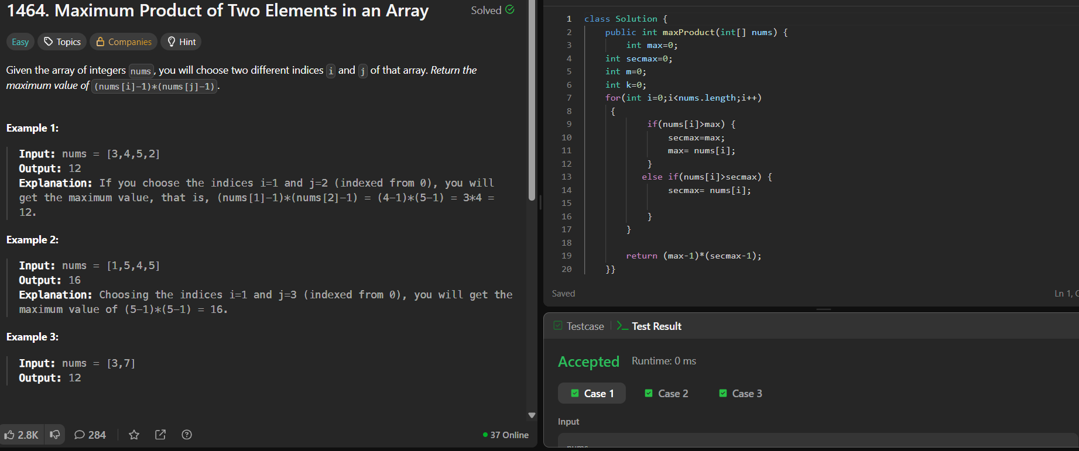
Q.1796. Second Largest ?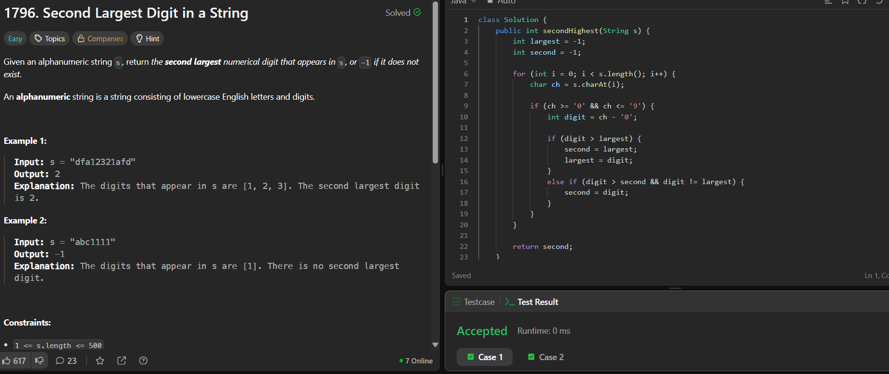

Q.162. Find Peak Element ?
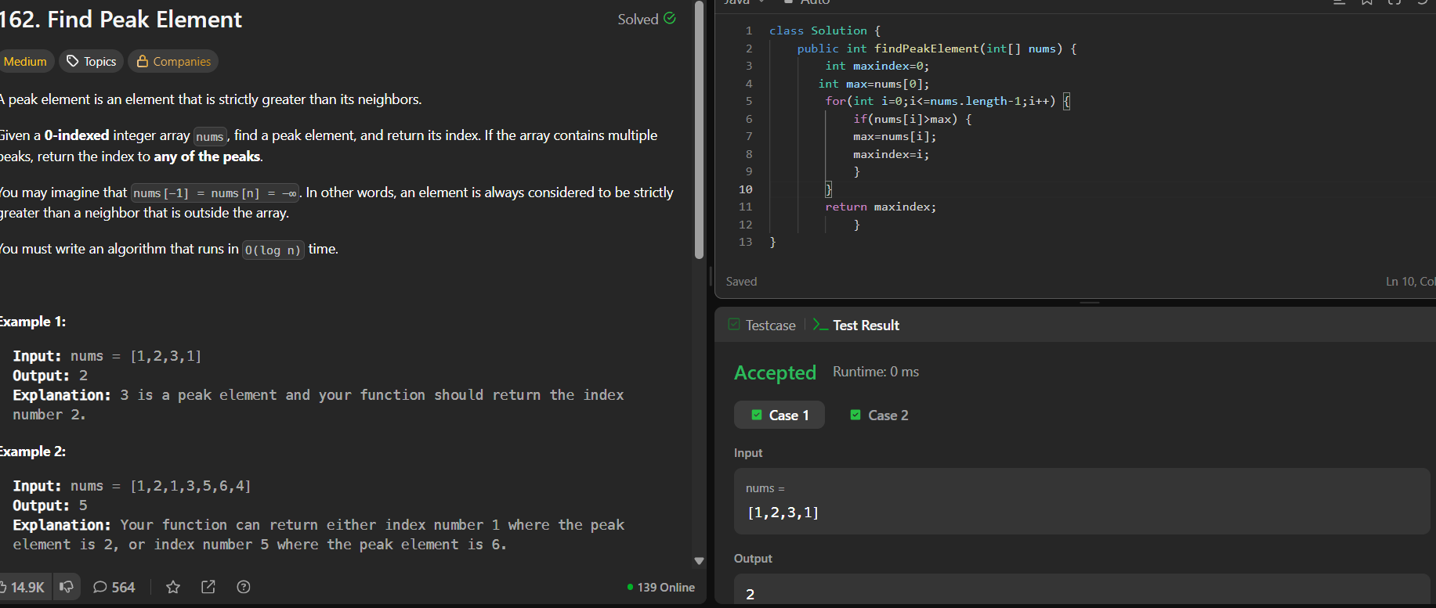
Q.33. Search in Rotated Sorted Array?
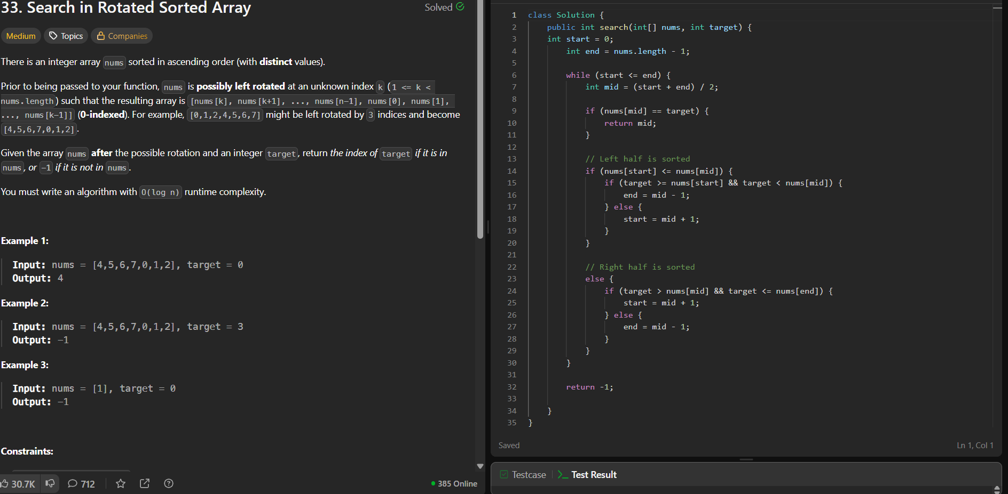
Q.3477. Fruits into Baskets ||?
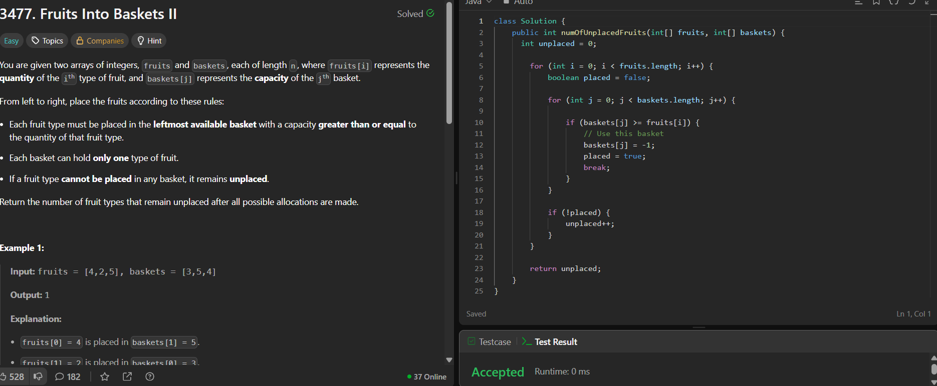
Q.121. Best Time to Buy and Sell Stock?
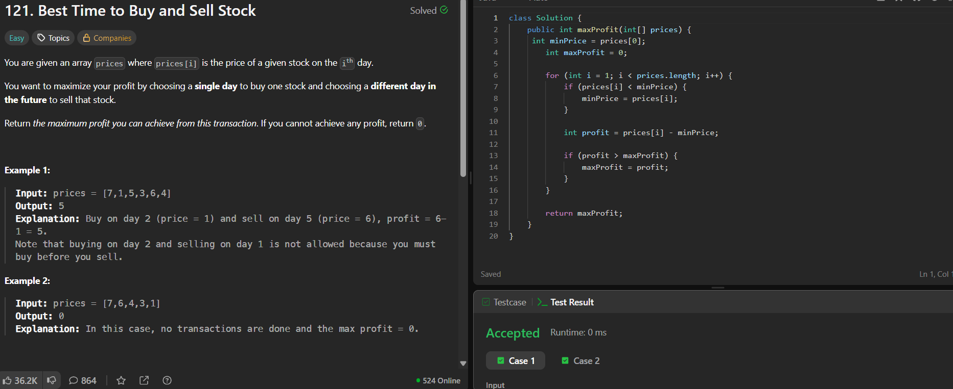
Q.1. Two Sum?
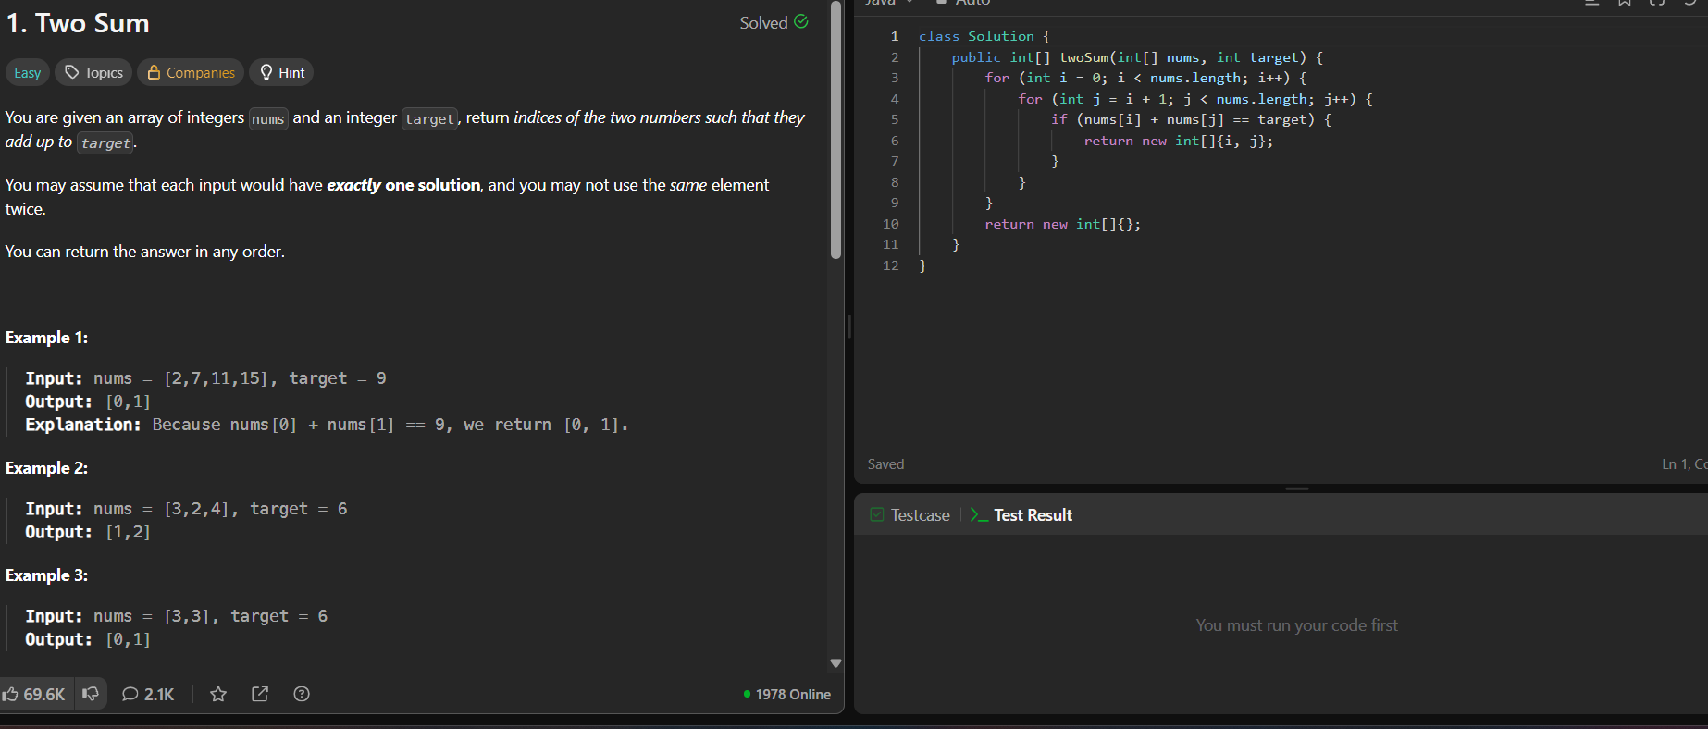
Q.1365. How Many Numbers Are Smaller Than the Current Number?
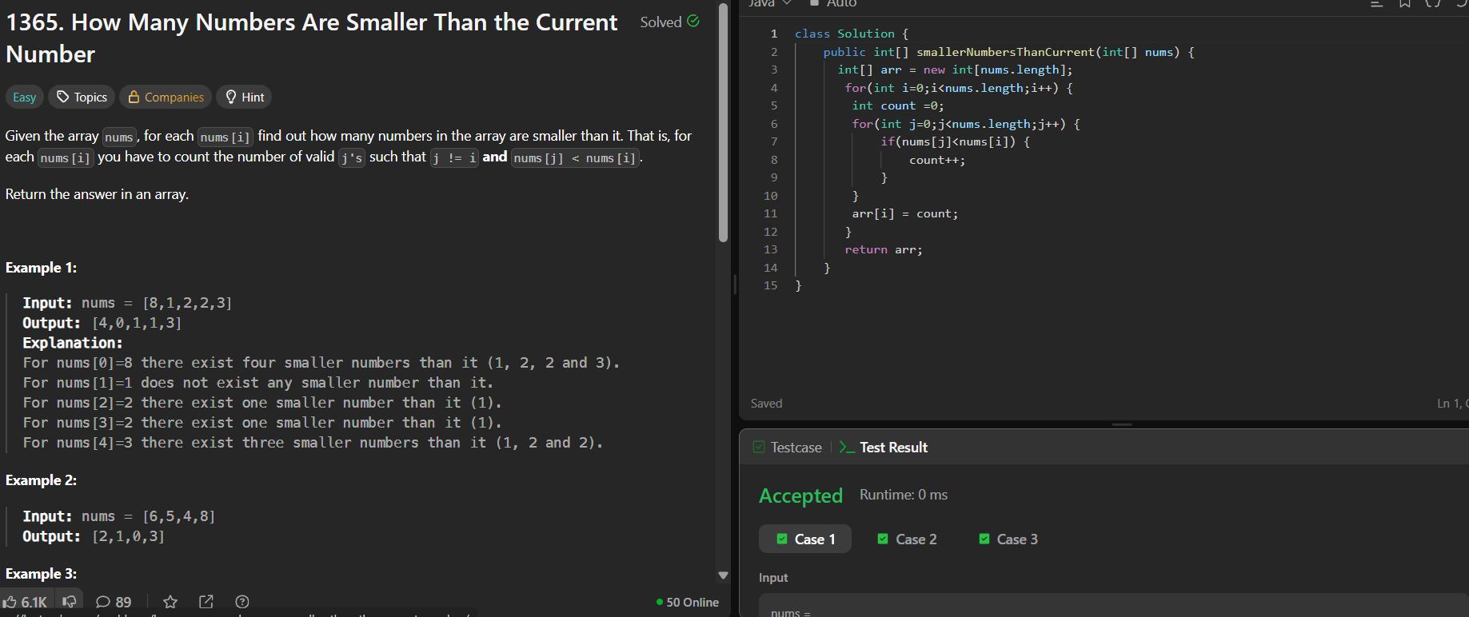
Q.628. Maximum Product of Three Numbers?
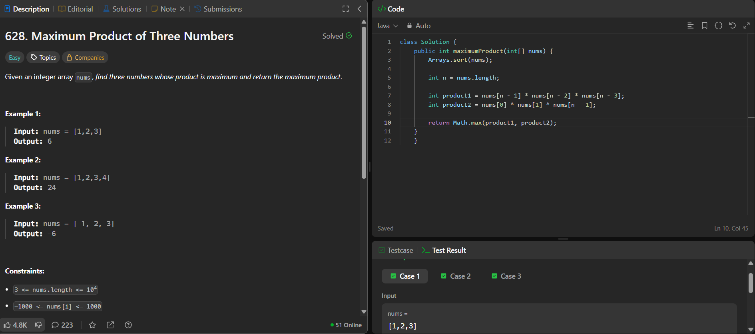
Q.26. Remove Duplicates from Sorted Array?
